Dear Parents and Guardians,

We are pleased to announce that our Child Care site has teamed up with the Healthy Sarasota County Collaborative to become a Healthy Sarasota County Child Care site. This effort aims to increase opportunities for healthy eating and active living. Healthy Sarasota County works within many sectors in our community (in schools, early childhood, after school, health care and workplace settings) to reach children and families where they live, study, work, and play.

Eating right and being physically active can be a challenge in today’s busy world. To address this, Healthy Sarasota County focuses on a consistent and simple 5-2-1-0 message:
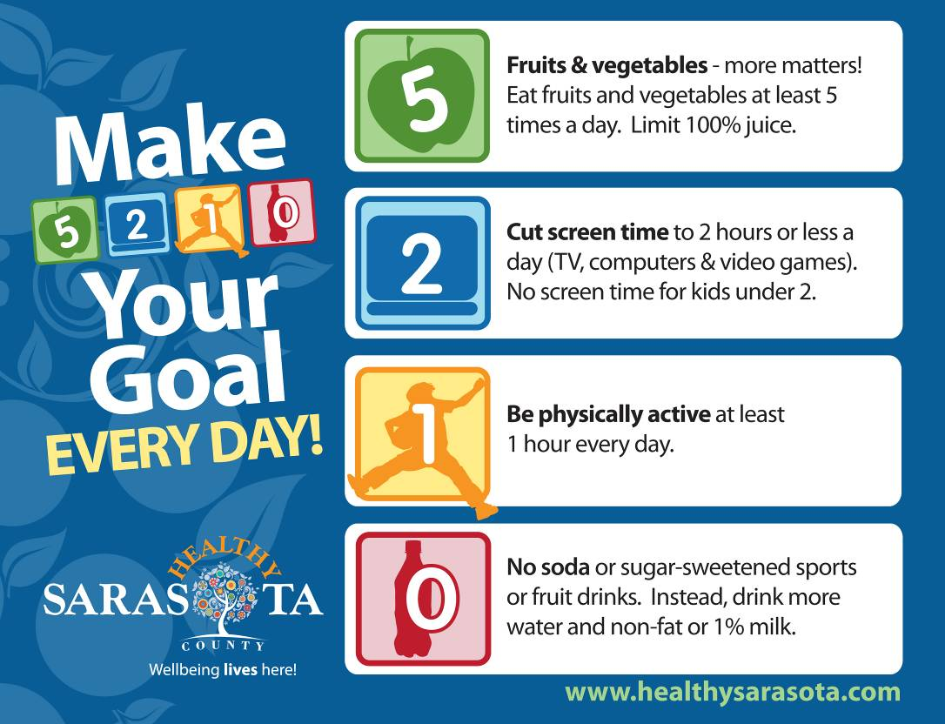

Our child care program will be working hard to incorporate the 5210 message into our daily activities and child care environment. As part of our commitment to this program and its message, you may receive parent-geared information, which will highlight the messages your child is learning at our center.

For more information about 5210 Every Day! and the Healthy Sarasota County effort , please visit www.healthysarasota.com.

Thank You!

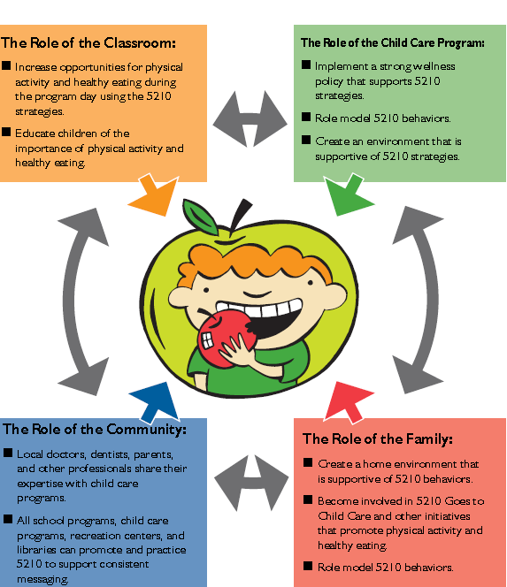
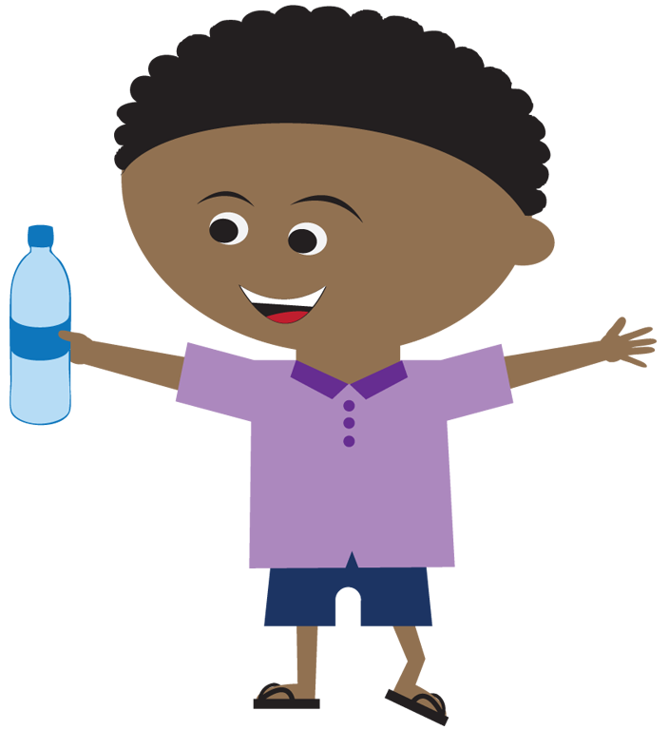

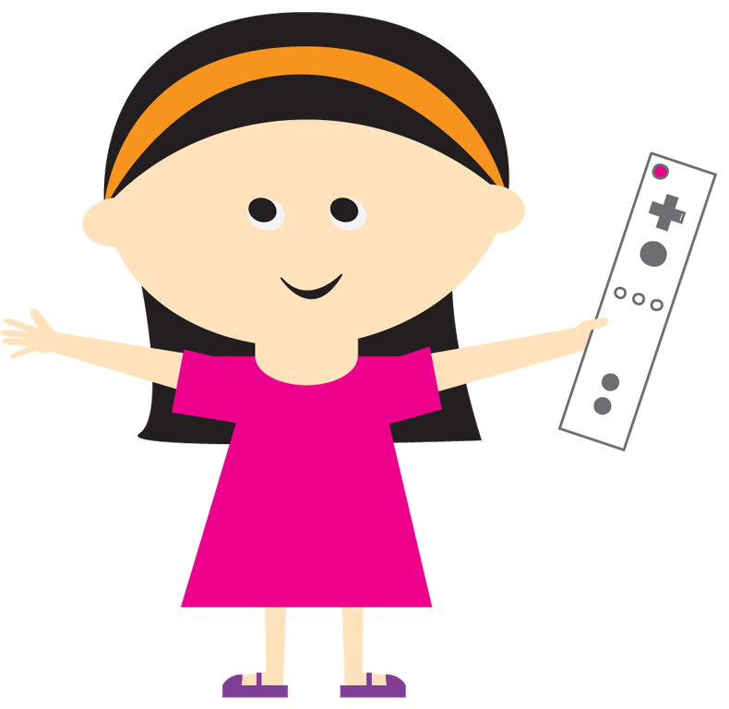
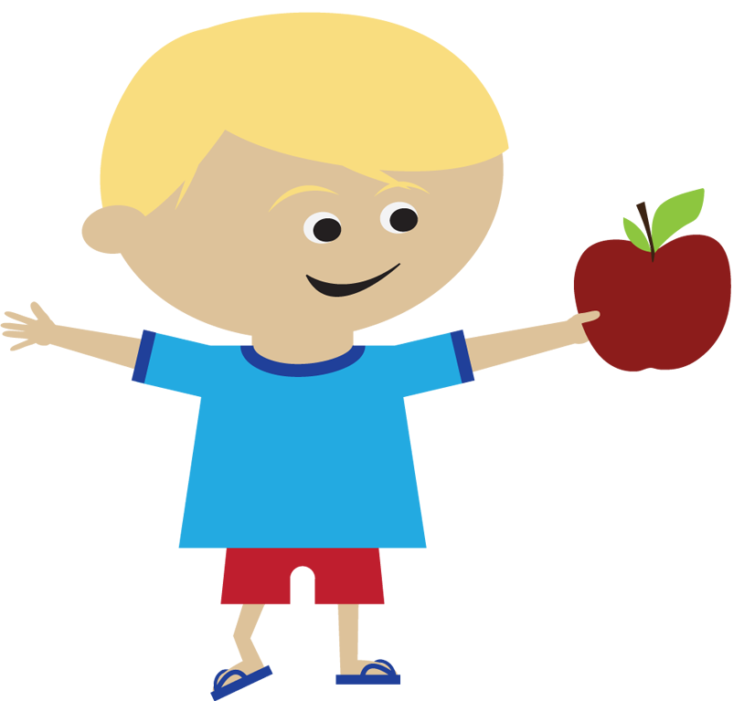
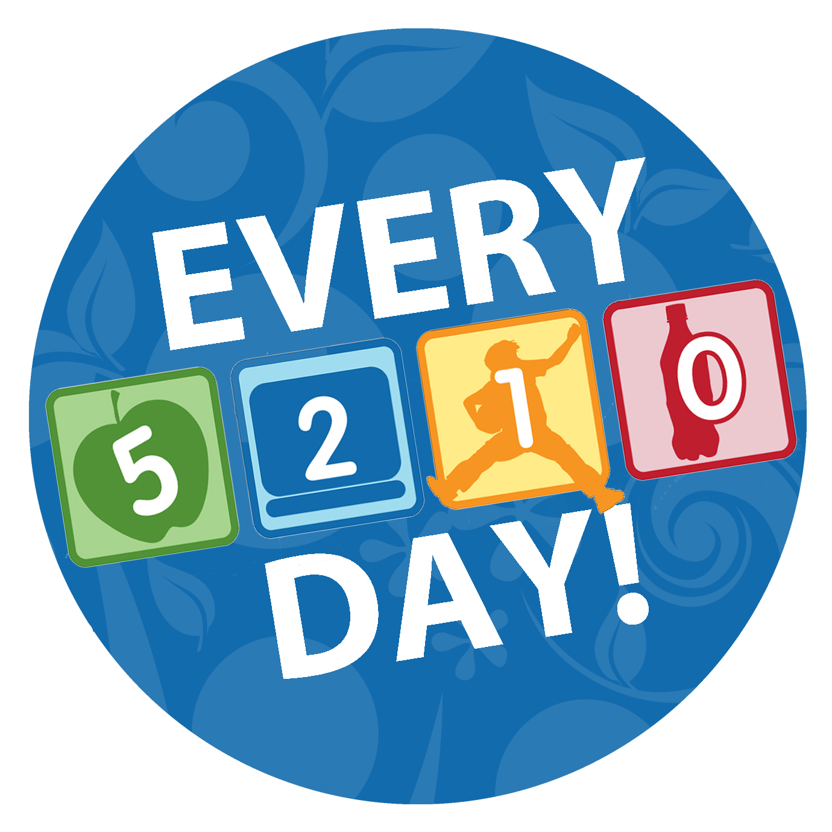
Everyone Has a Role to Play
The Role of the Classroom
- Increase opportunities for physical activity and healthy eating during the program day using the 5210 strategies.

- Educate children of the importance of physical activity and healthy eating.

The Role of the Child Care Site:
- Implement a strong wellness policy that supports 5210 strategies.

- Role model 5210 behaviors.

- Create an environment that is supportive of 5210 strategies.

The Role of the Family
- Create a home environment that is supportive of 5210 behaviors.

- Become involved in efforts that promote physical activity and healthy eating.

- Role model 5210 behaviors.

The Role of the Community
- Local doctors, dentists, parents, and other professionals share their expertise with child care programs.

- All school programs, child care programs, recreation centers and libraries can promote and practice 5210 to support consistent messaging.

